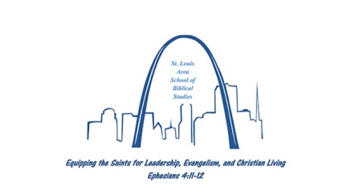 | St. Louis Area School of Biblical Studies  25 N. Greenmount Rd, Belleville, IL 62221  618-799-6309 kelvin_pugh@att.net
ELDERS  Rodney Crouch  Mike Kirk  Curtis Moore  DIRECTOR  Kelvin A Pugh  INSTRUCTORS  Jordan Pugh  Kelvin Pugh | January 1, 2020  Brothers & Sisters,  The 5th quarter of the STL School of Biblical Studies will begin on Tuesday January 7tht beginning at 7pm and concluding at 8:50pm.  Our first class will be The Life of Christ 7pm-7:50pm taught by Jordan, the second class will be Sermon Preparation and Delivery from 8:00pm-8:50pm taught by Kelvin.  The life of Christ is one every Christian should imitate. Learning more about Him and how He lived will help each of us transform our lives into His image. The class will study the birth, life, death, resurrection, and ascension of Christ.  Sermon Preparation and Delivery will help men prepare Bible based sermons and to help deliver them in such a way that God will be glorified and the hearers will be edified. Sisters can also attend the class to learn how to prepare lessons for women’s Bible classes and lectures.  If you have been interested in attending the classes, this would be the perfect quarter to come see what the STL School of Biblical Studies is all about! Want to know more? Talk to some of the students who have been attending and ask how the classes have been impacting their lives. If you have questions for me, I would be more than willing to sit down with you and discuss those questions.  See you in class.  Kelvin

